







UID /dashboard/

ReadySetResource.com

Contents

16.1 - Dashboard (Admin Privileges) 3

16.1 - Dashboard (Basic Privileges) 4

16.2 - Settings (Both Privileges) 5

16.3 - Editable Idea (Both Privileges) 6

16.4 - Employee Store (Admin Privileges) 7

16.4 - Employee Store (Basic Privileges) 8

16.5 - Holidays (Admin Privileges) 9

16.5 - Holidays (Basic Privileges) 10

16.6 - Ideas (Both Privileges) 11

16.7 - Meetings (Admin Privileges) 12

16.7 - Meetings (Basic Privileges) 13

16.8 - Messenger (Both Privileges) 14

16.9 - Rota (Admin Privileges) 15

16.9 - Rota (Basic Privileges) 16

16.10 - Updates (Admin Privileges) 17

16.10 - Updates (Basic Privileges) 18

16.11 - Company Settings (Admin Privileges) 19

16.12 - Add User Type (Admin Privileges) 20

16.13 - Editable Meeting (Admin Privileges) 21

16.14 - Editable Update (Admin Privileges) 22

16.15 - Editable Item (Admin Privileges) 23

16.16 - Employee Management (Admin Privileges) 24

16.17 - UID /dashboard/ Work Log 25

# 16.1 - Dashboard (Edit Privileges)

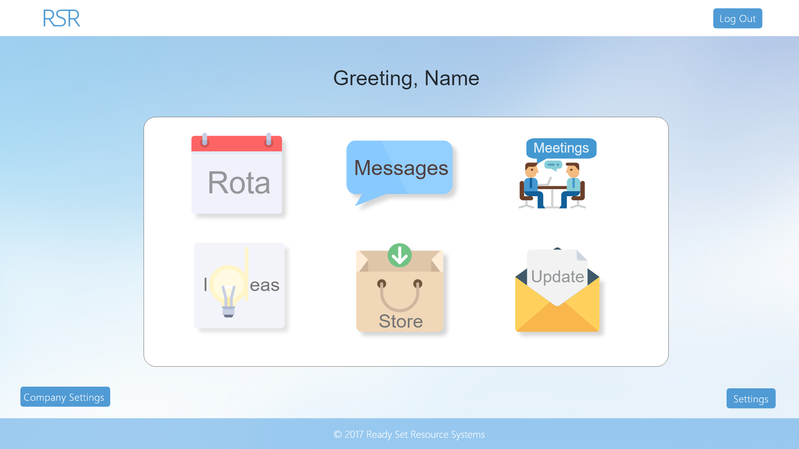

Input Permissible: None

Error Messages: None

# 16.1 - Dashboard (View Privileges)

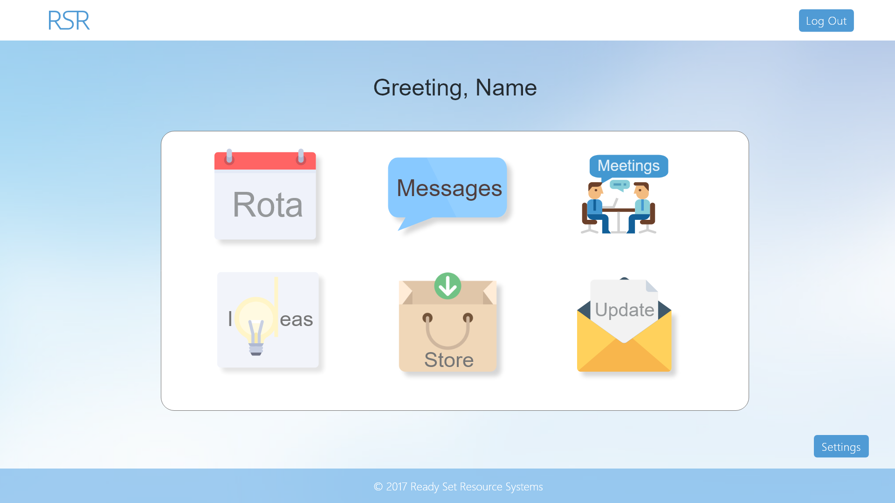

Input Permissible: None

Error Messages: None

# 16.2 - Settings (Both Privileges)

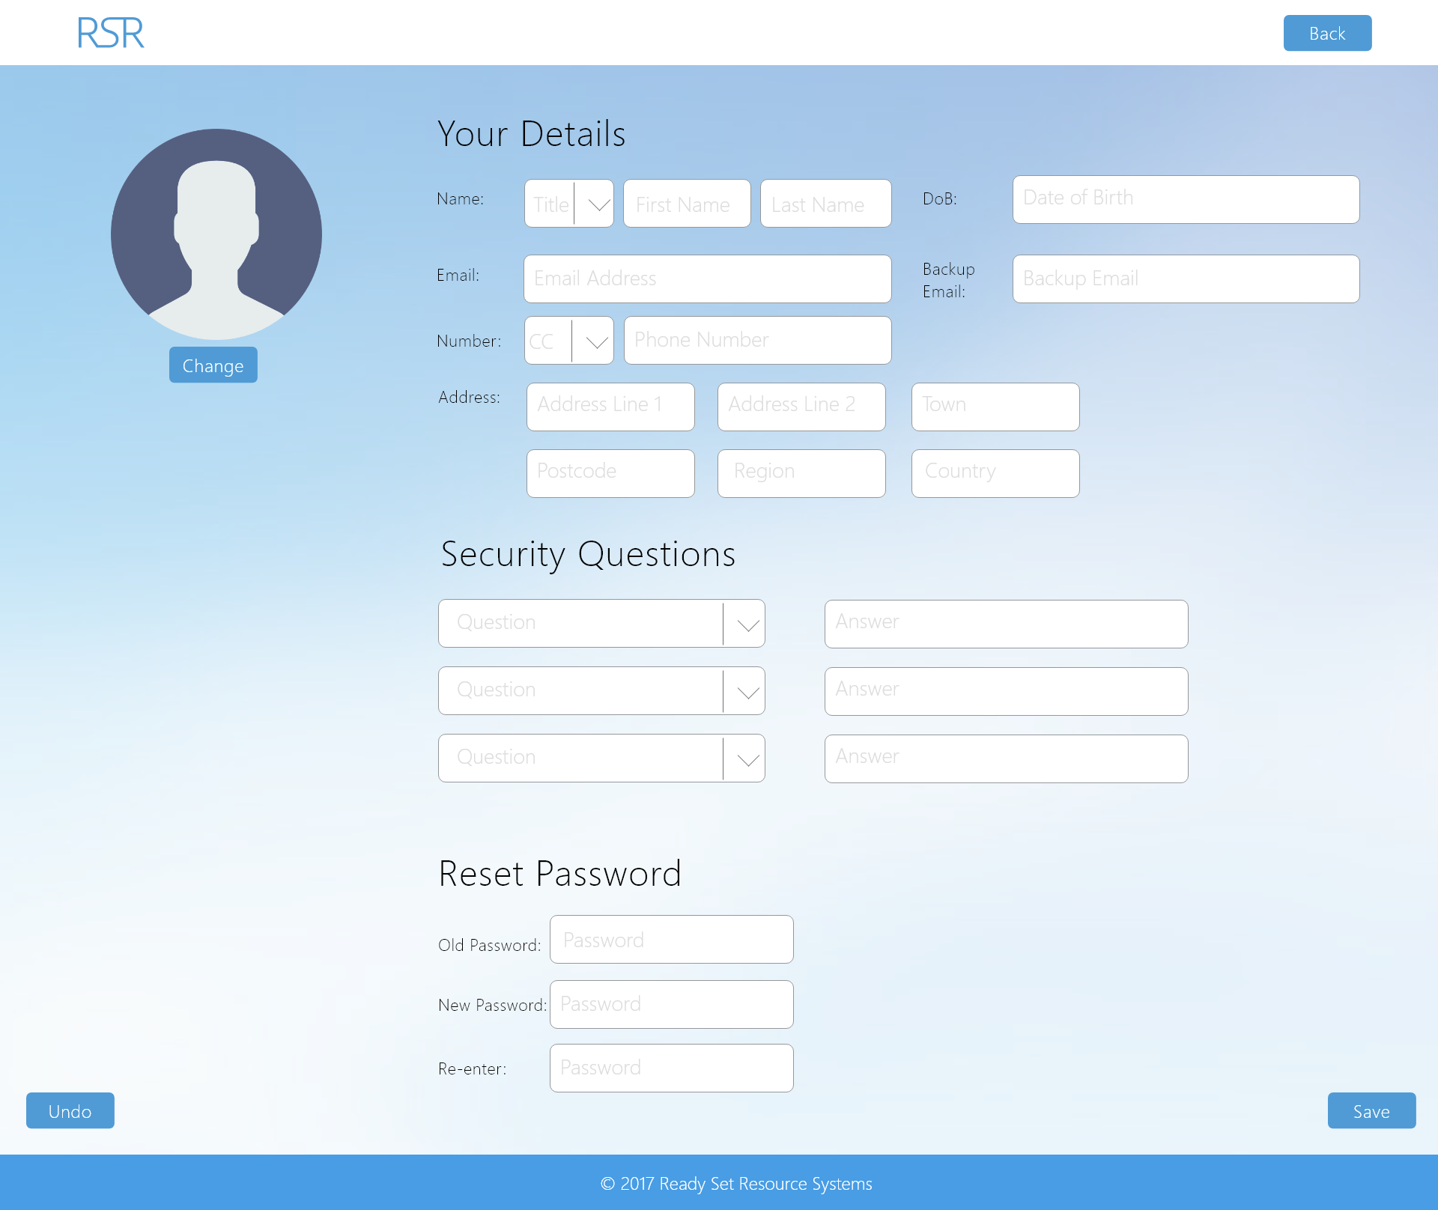

Input Permissible: - Title - Address Line 1

- First Name - Address Line 2

- Last Name - Town

- Date of Birth - Postcode

- Email - Image (Profile Picture)

- Backup Email - Password

- Country Code - New Password

- Phone Number - Repeat New Password

- Security Question 1 - Security Answer 1

- Security Question 1 - Security Answer 2

- Security Question 1 - Security Answer 3

Error Messages: - ‘Please complete all fields’

- ‘Old password is incorrect’

- ‘Passwords do not match’

- ‘Email address in wrong format’

# 16.3 - Editable Idea (Both Privileges)

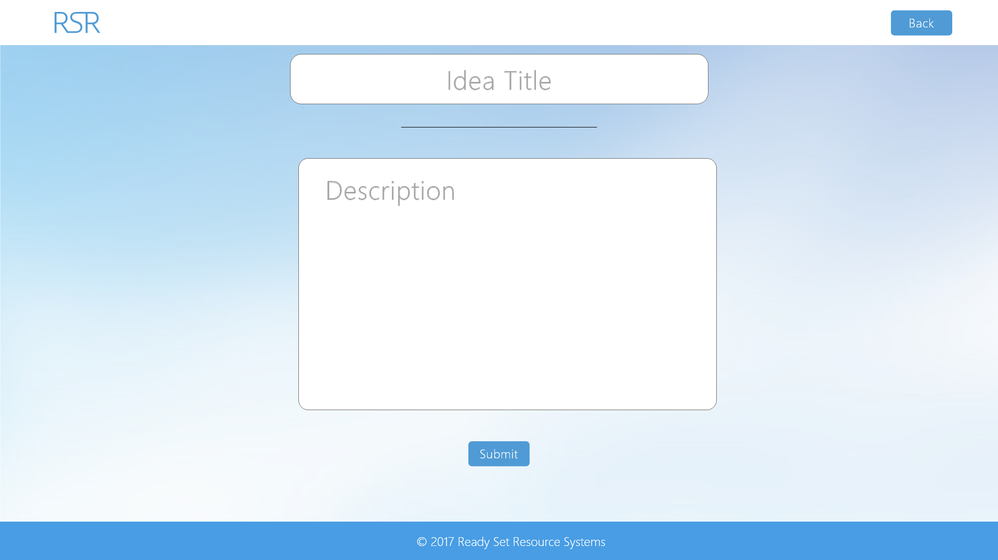

Input Permissible: - Idea Title

- Idea Description

Error Messages: - ‘Old password is incorrect’

- ‘Field is too long’

# 16.4 - Employee Store (Edit Privileges)

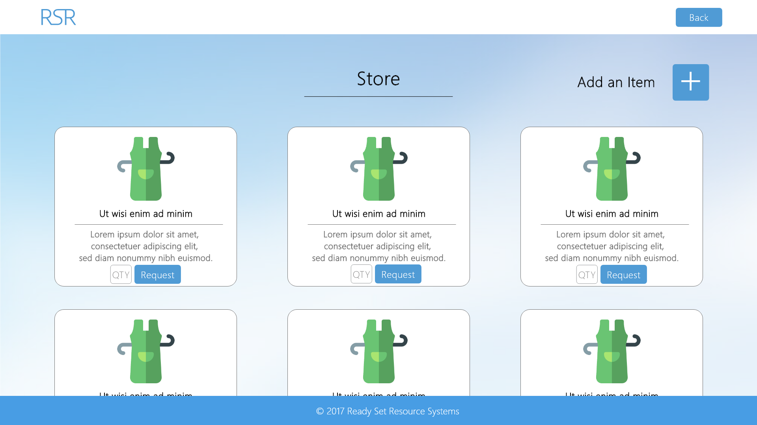

Input Permissible: None

Error Messages: None

# 16.4 - Employee Store (View Privileges)

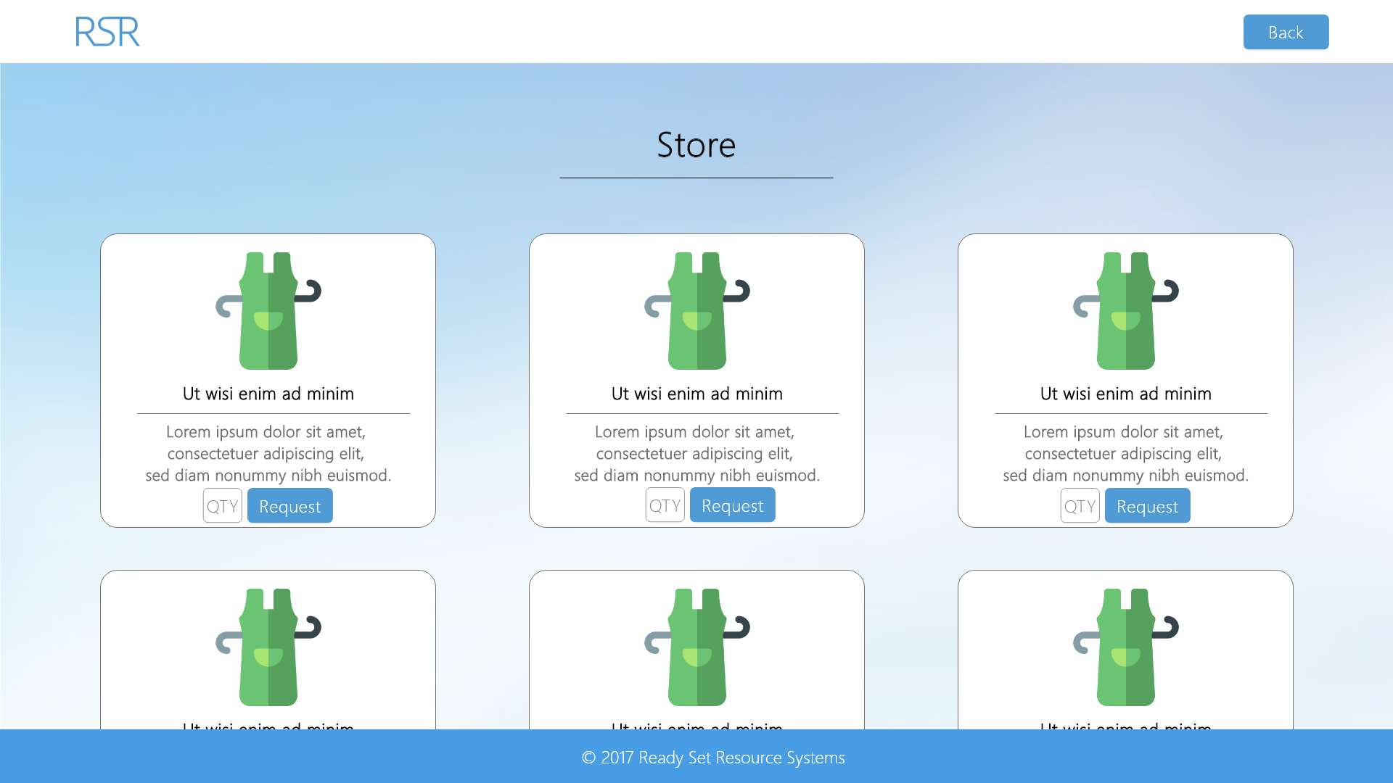

Input Permissible: None

Error Messages: None

# 16.5 - Holidays (Edit Privileges)

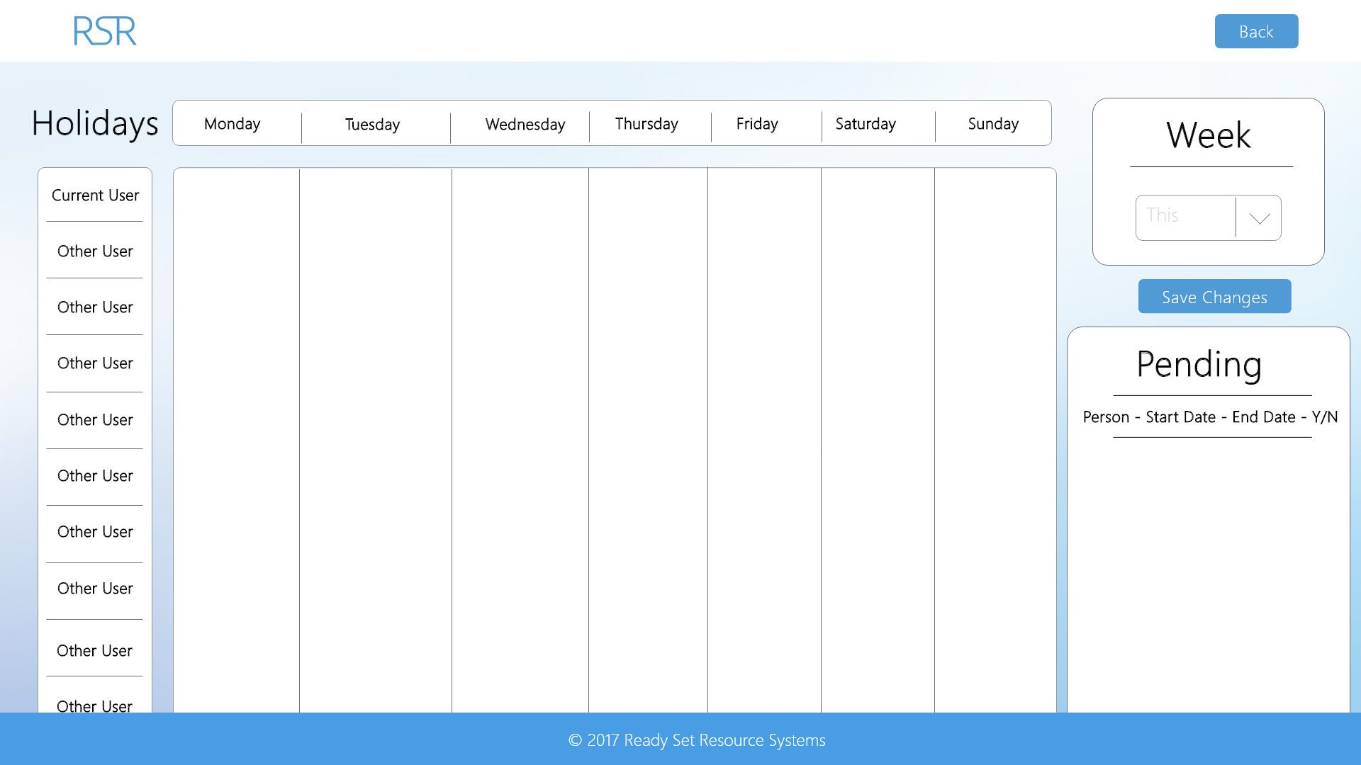

Input Permissible: - Week

- All holidays

Error Messages: - ‘Time in wrong format’

- ‘Date in wrong format’

# 16.5 - Holidays (View Privileges)

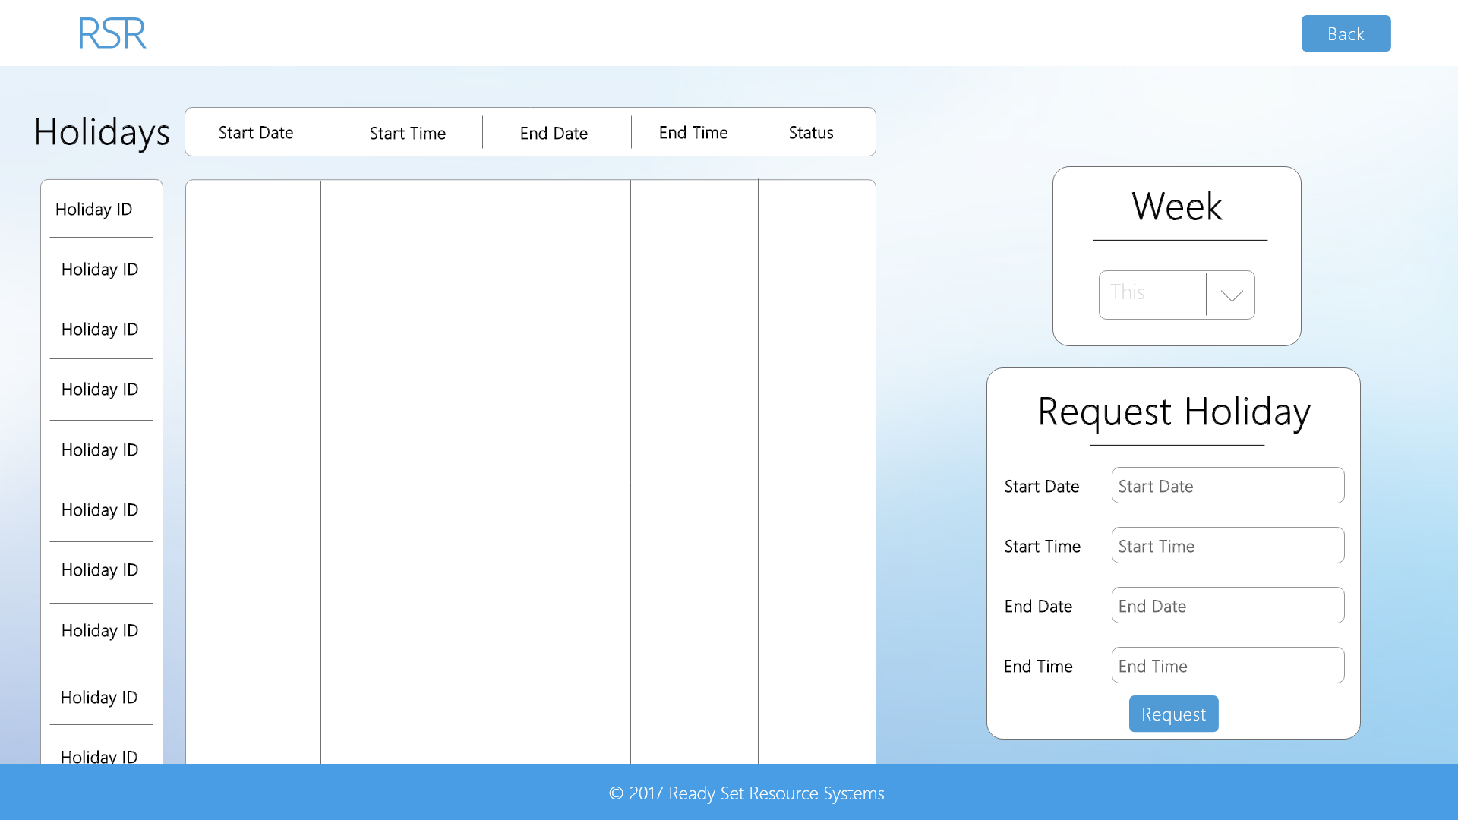

Input Permissible: - Week

- All holidays

- Start Date

- Start Time

- End Date

- End Time

Error Messages: - ‘Time in wrong format’

- ‘Date in wrong format’

# 16.6 - Ideas (Both Privileges)

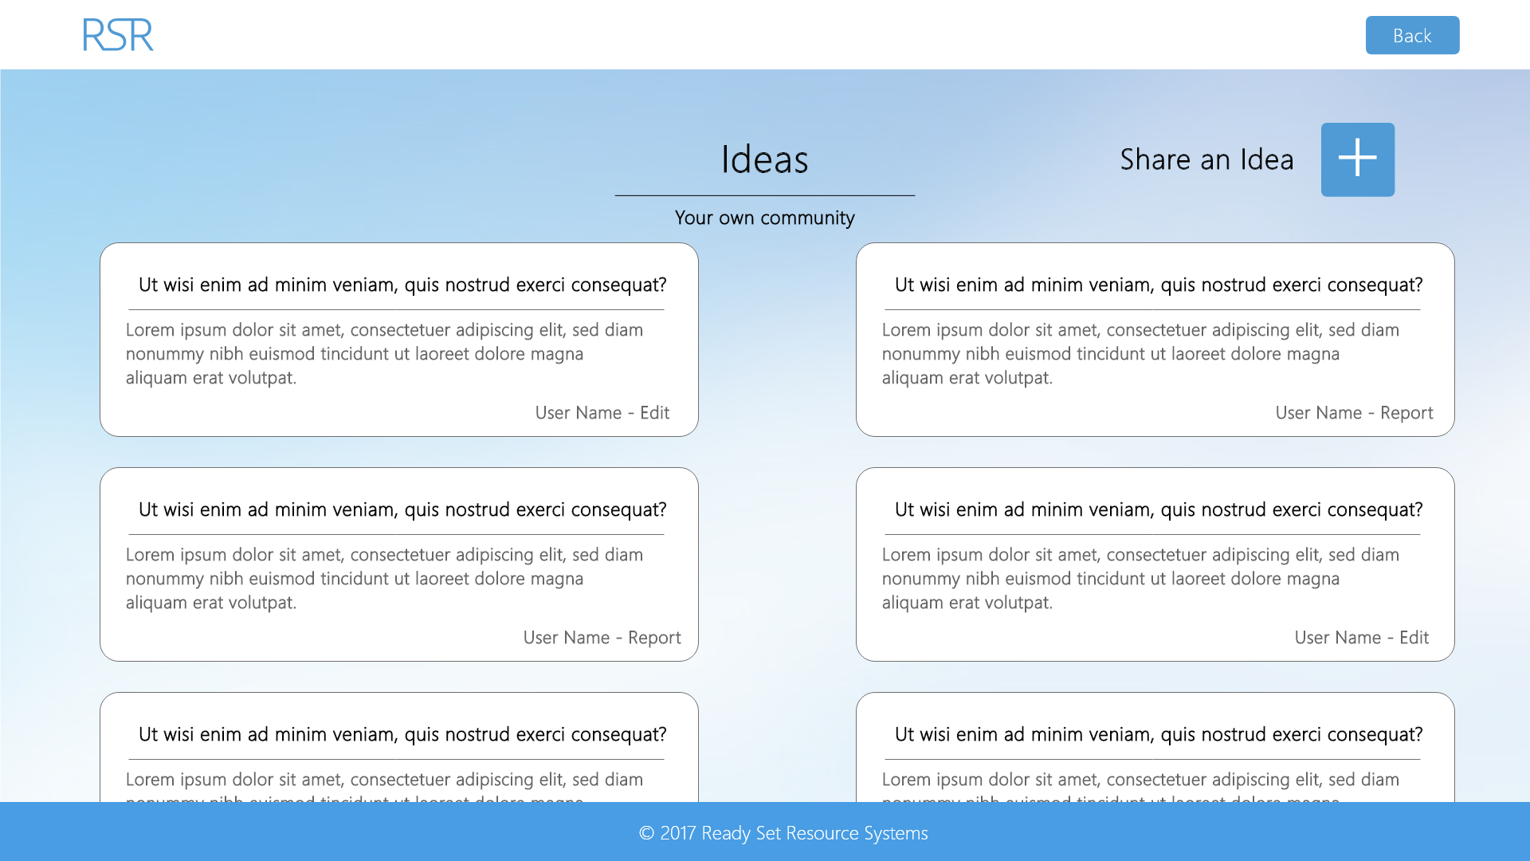

Input Permissible: None

Error Messages: None

# 16.7 - Meetings (Edit Privileges)

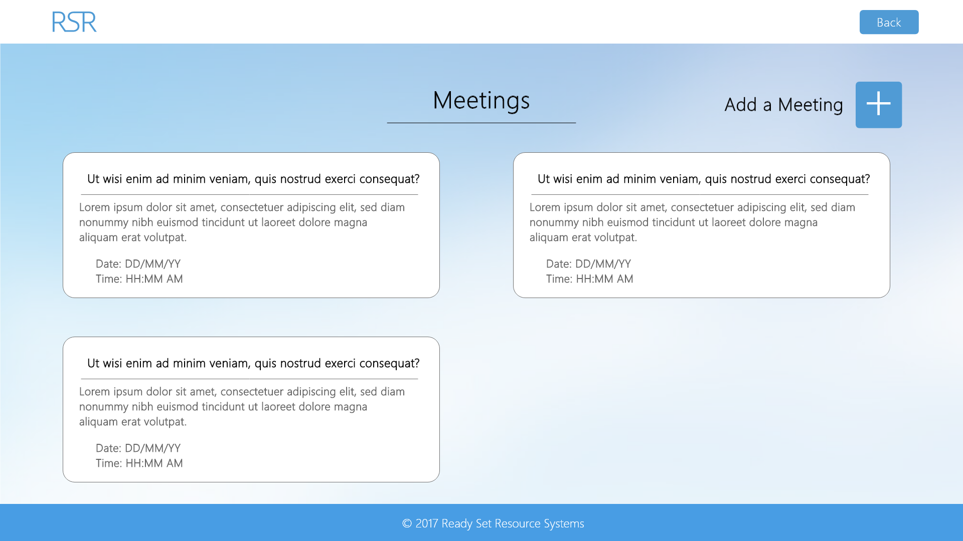

Input Permissible: None

Error Messages: None

# 16.7 - Meetings (View Privileges)

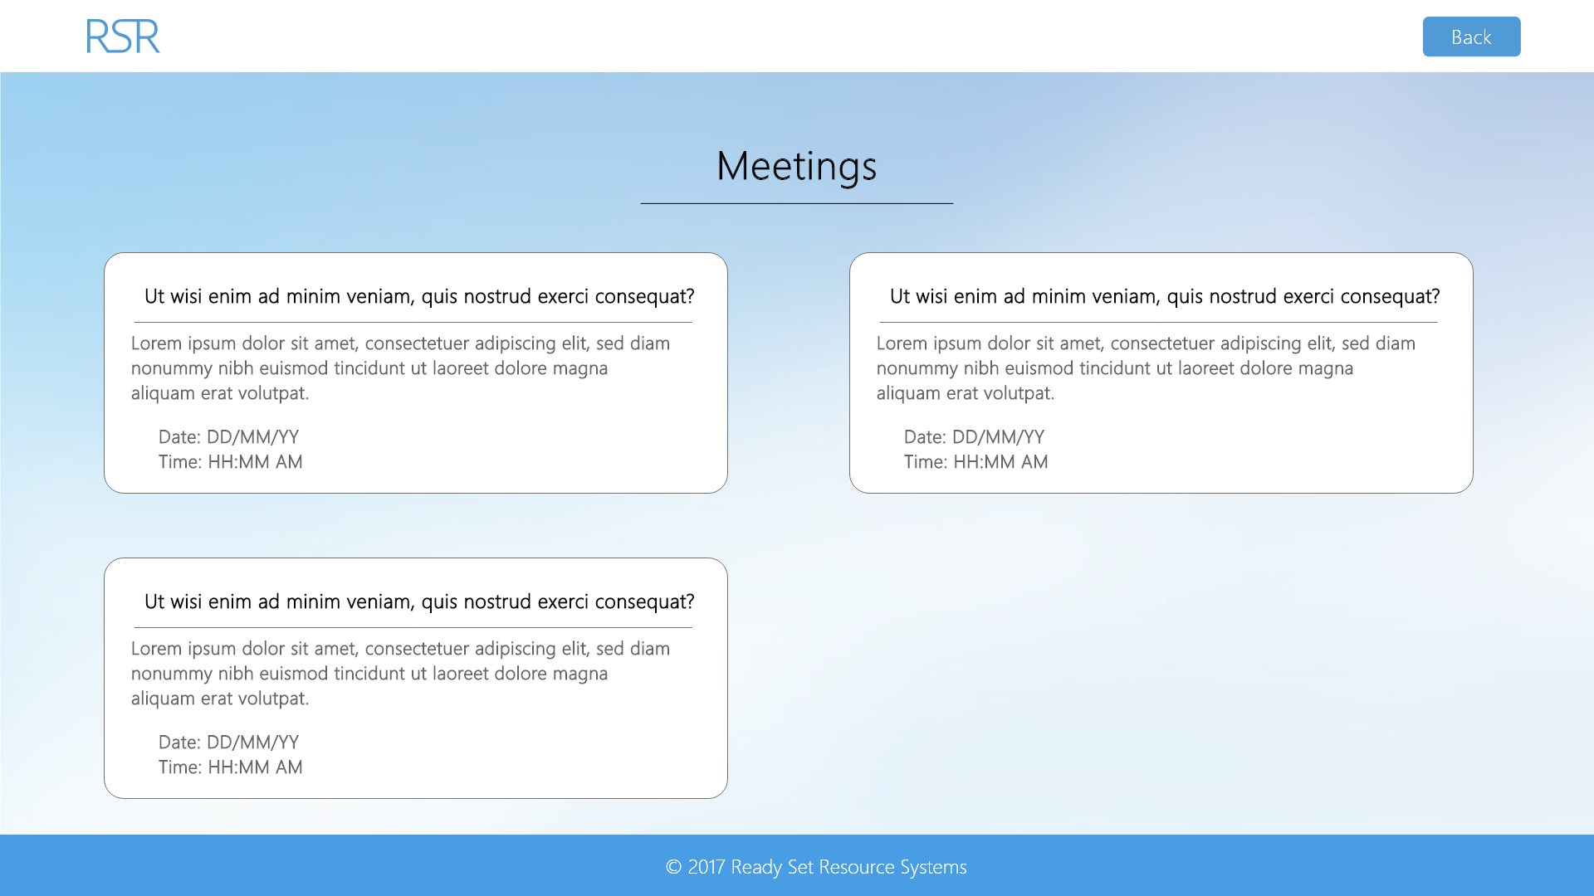

Input Permissible: None

Error Messages: None

# 16.8 - Messenger (Both Privileges)

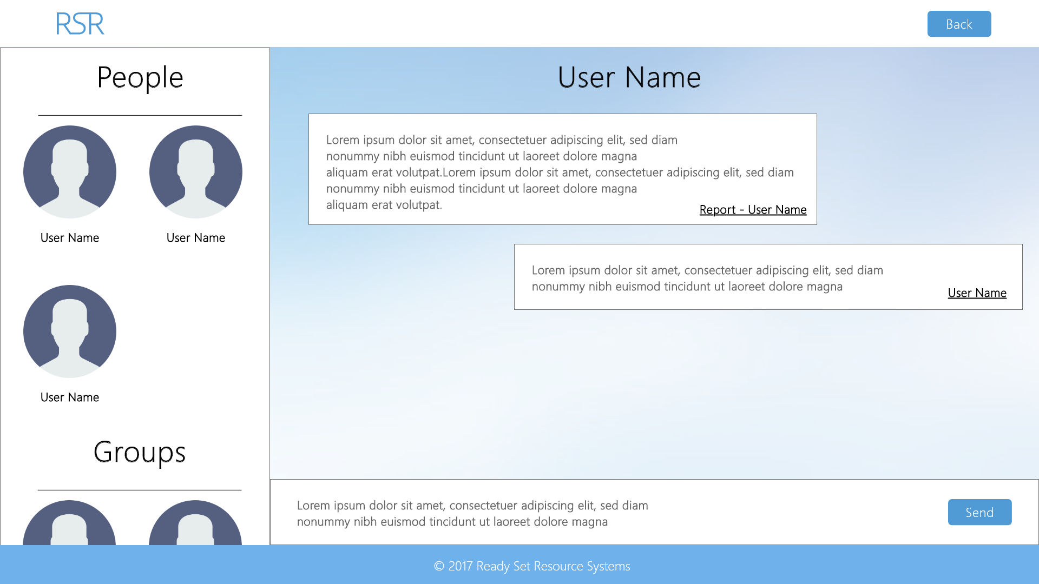

Input Permissible: - Message

Error Messages: - ‘Message too long’

- ‘Cannot upload a photo’

# 16.9 - Rota (Edit Privileges)

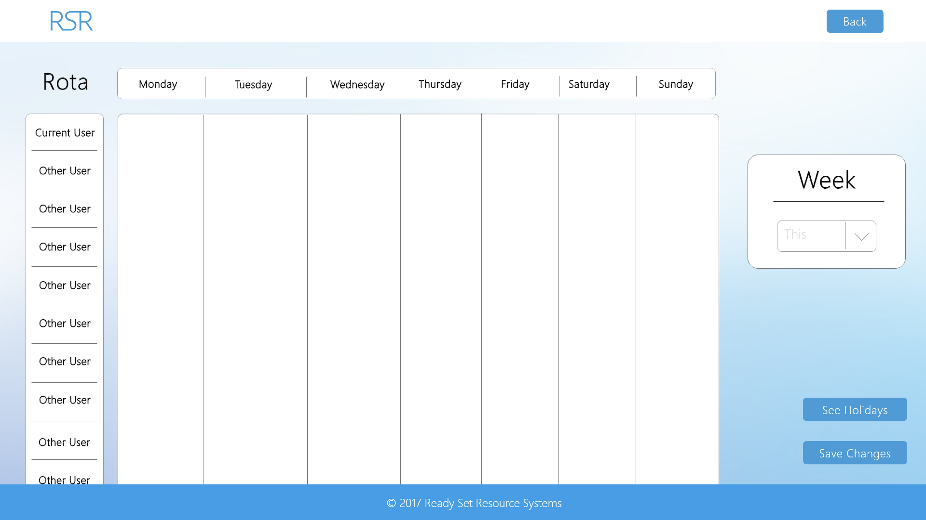

Input Permissible: - Week

- All shifts with

- Start Date

- Start Time

- End Date

- End Time

Error Messages: - ‘Time in wrong format’

- ‘Date in wrong format’

# 16.9 - Rota (View Privileges)

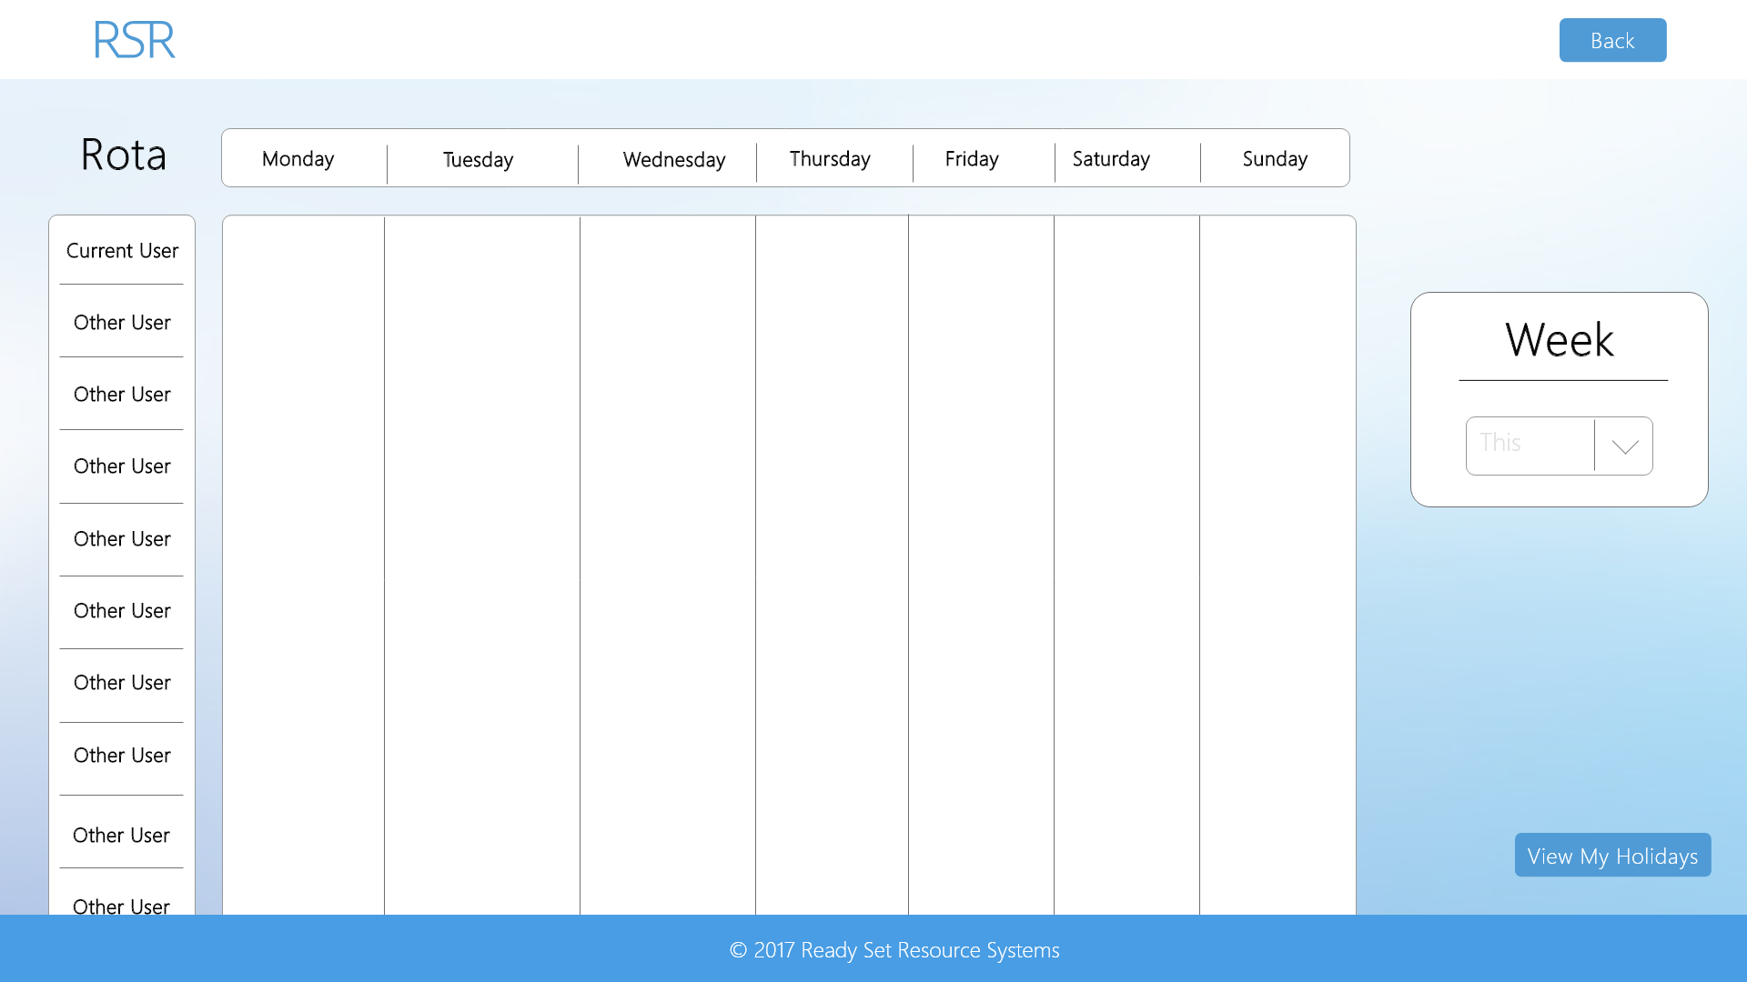

Input Permissible: - Week

Error Messages: - ‘Time in wrong format’

- ‘Date in wrong format’

# 16.10 - Updates (Edit Privileges)

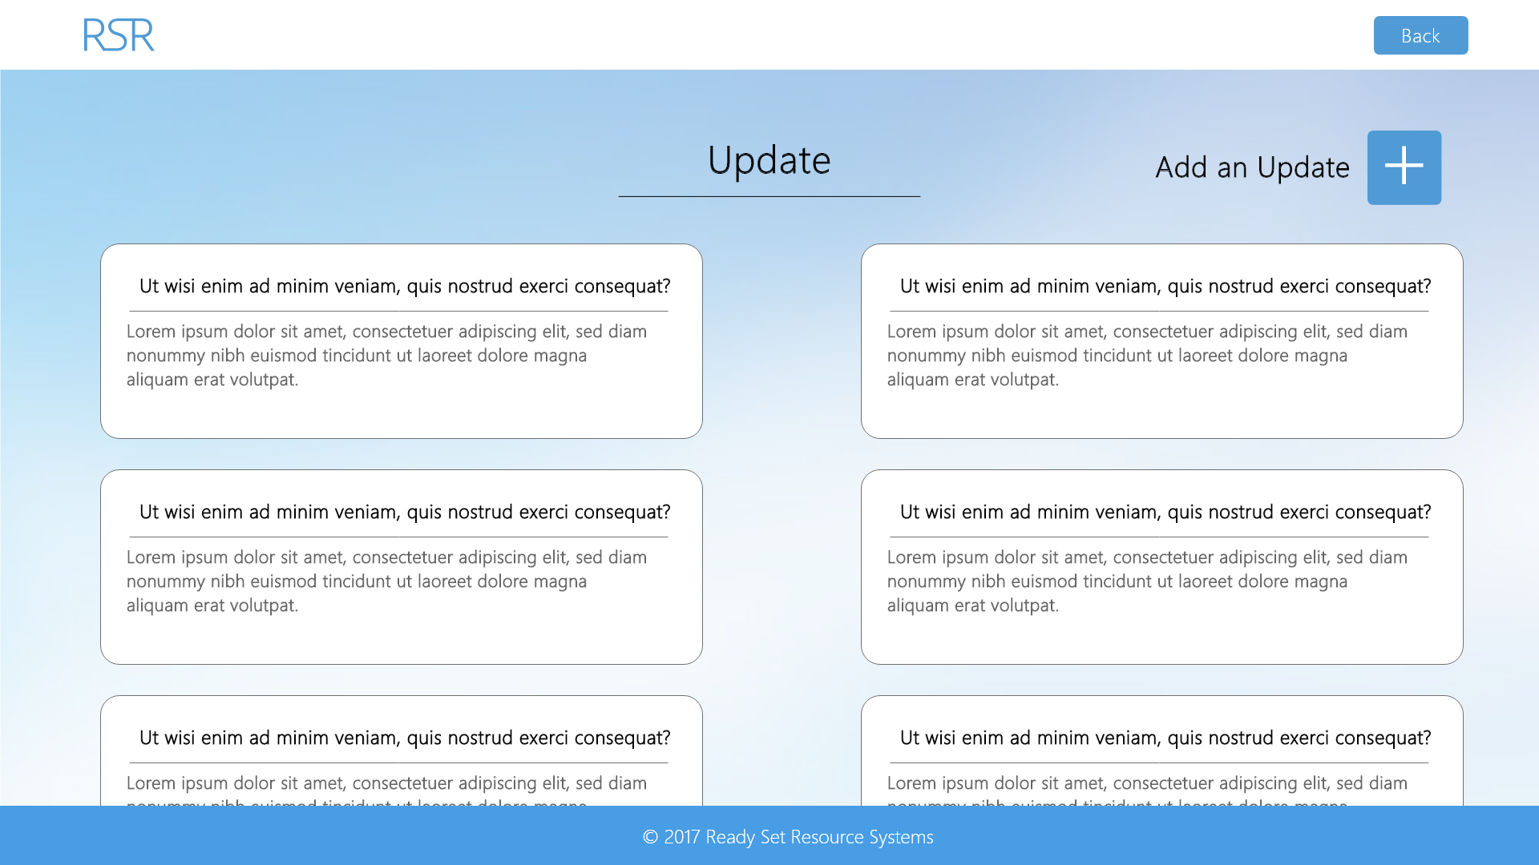

Input Permissible: None

Error Messages: None

# 16.10 - Updates (View Privileges)

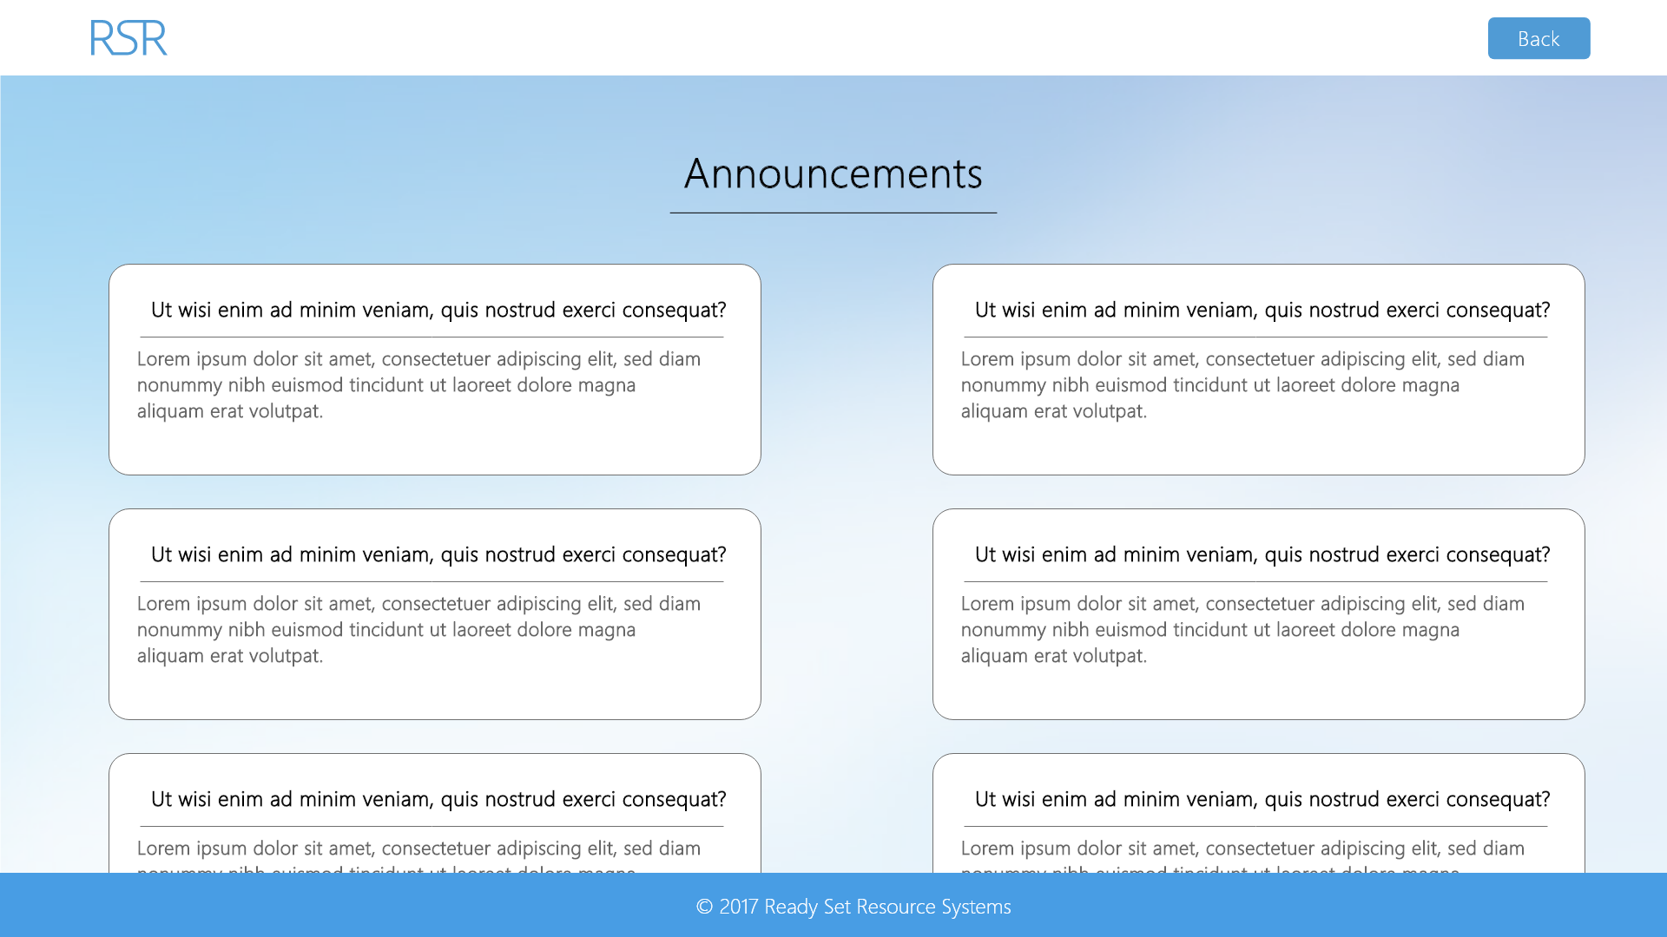

Input Permissible: None

Error Messages: None

# 16.11 - Company Settings (Edit Privileges)

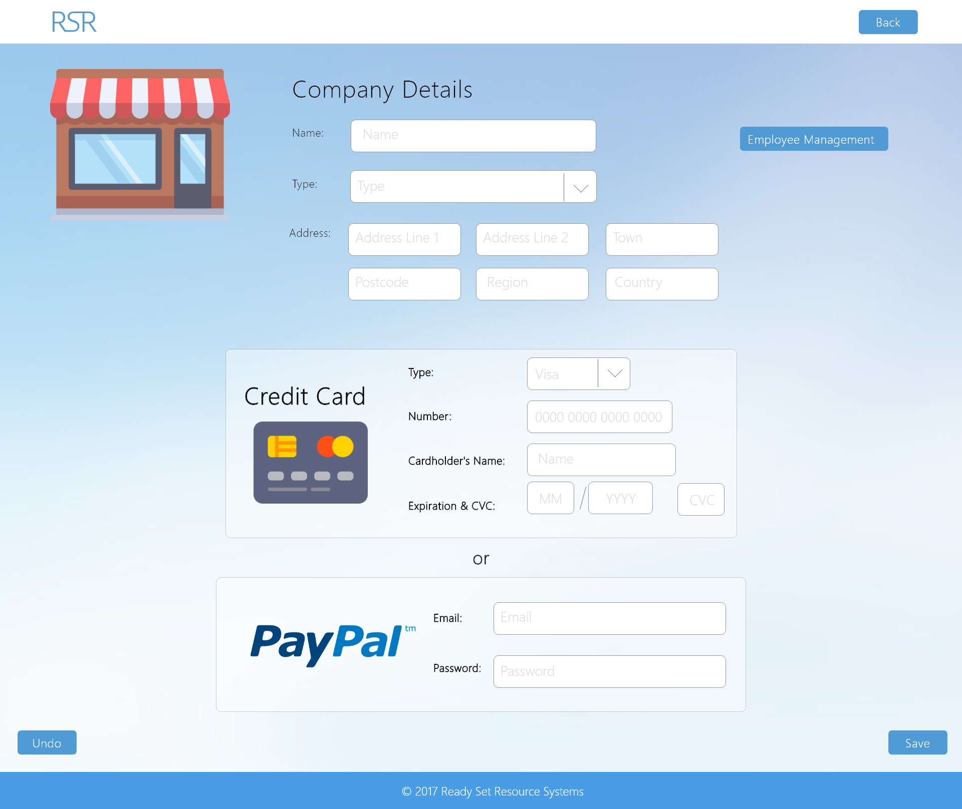

Input Permissible: - Name

- Type

- Address Line 1

- Address Line 2

- Postcode

- Town

- Region

- Country

- Card Type

- Card Number

- Cardholder’s Name

- Expiration

- CVC

Error Messages: - ‘Please complete all fields’

- ‘Email address in wrong format’

- ‘Number in wrong format’

# 16.12 - Add User Type (Edit Privileges)

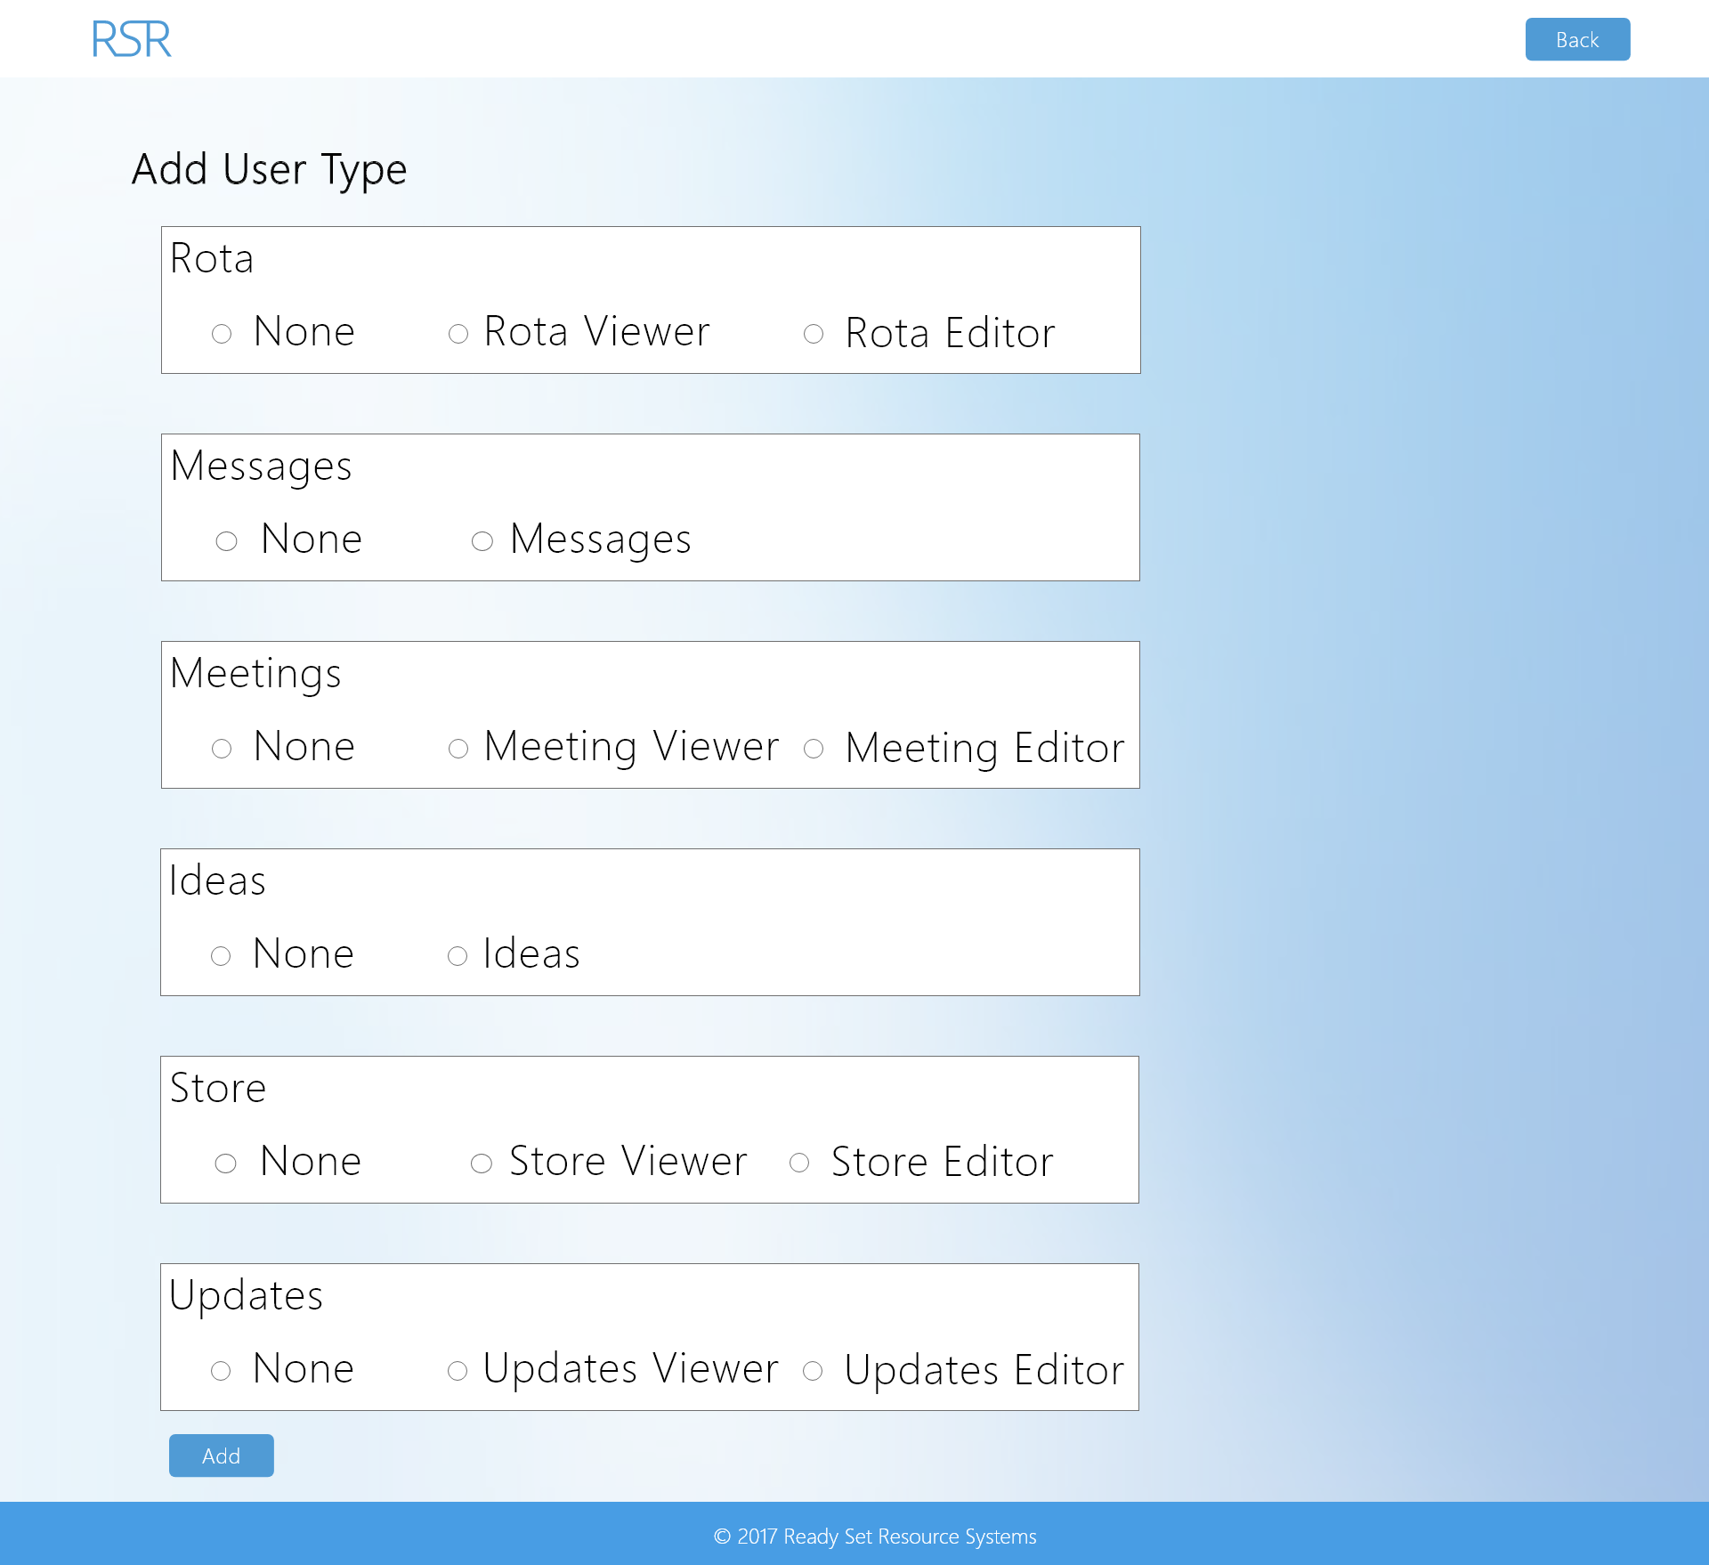

Input Permissible: - Rota Type

- Messages Type

- Meetings Type

- Ideas Type

- Store Type

- Updates Type

Error Messages: - ‘Please complete all fields’

# 16.13 - Editable Meeting (Edit Privileges)

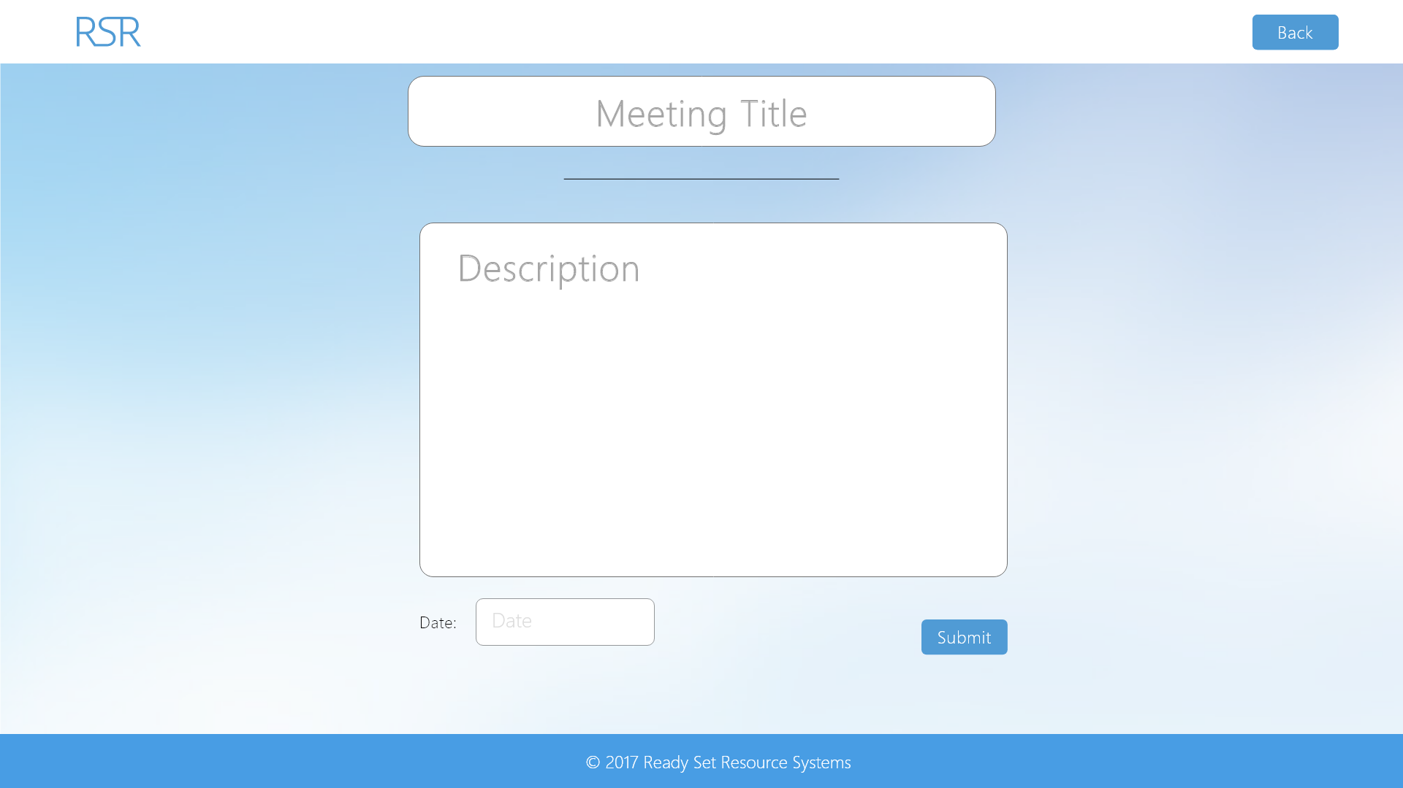

Input Permissible: - Meeting Title

- Meeting Description

- Meeting Date

Error Messages: - ‘Old password is incorrect’

- ‘Field is too long’

# 16.14 - Editable Update (Edit Privileges)

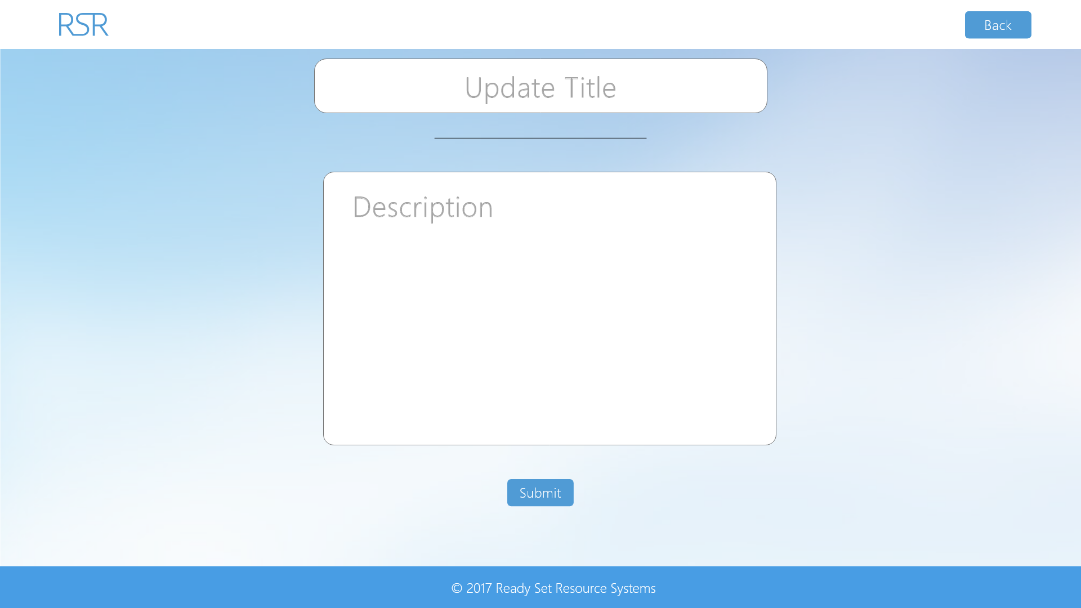

Input Permissible: - Update Title

- Update Description

Error Messages: - ‘Old password is incorrect’

- ‘Field is too long’

# 16.15 - Editable Item (Edit Privileges)

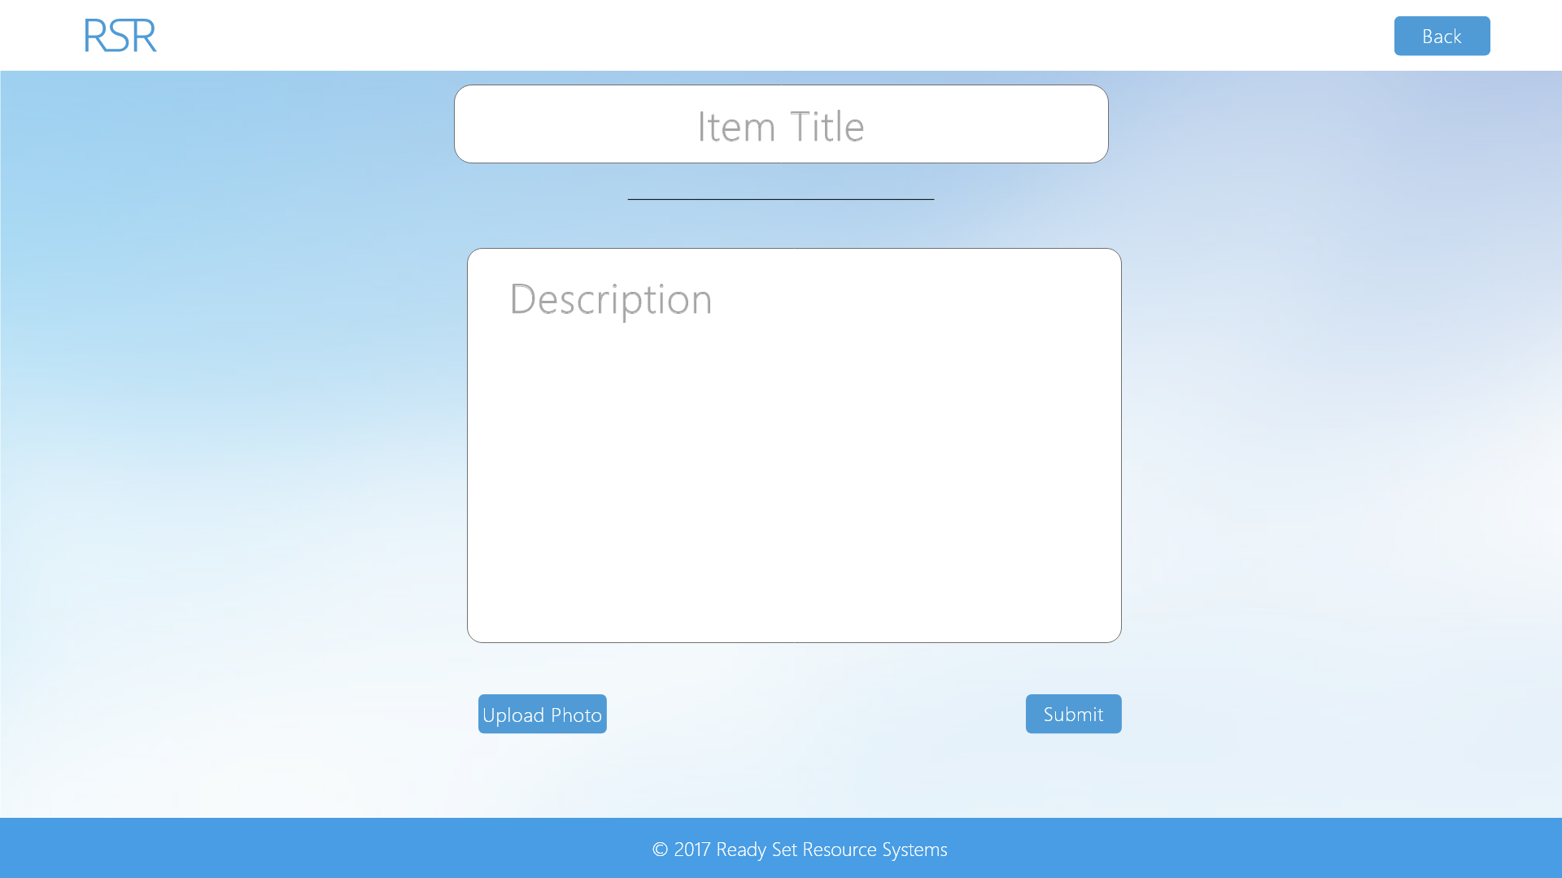

Input Permissible: - Item Title

- Item Description

- Item Photo

Error Messages: - ‘Old password is incorrect’

- ‘Field is too long’

# 16.16 - Employee Management (Edit Privileges)

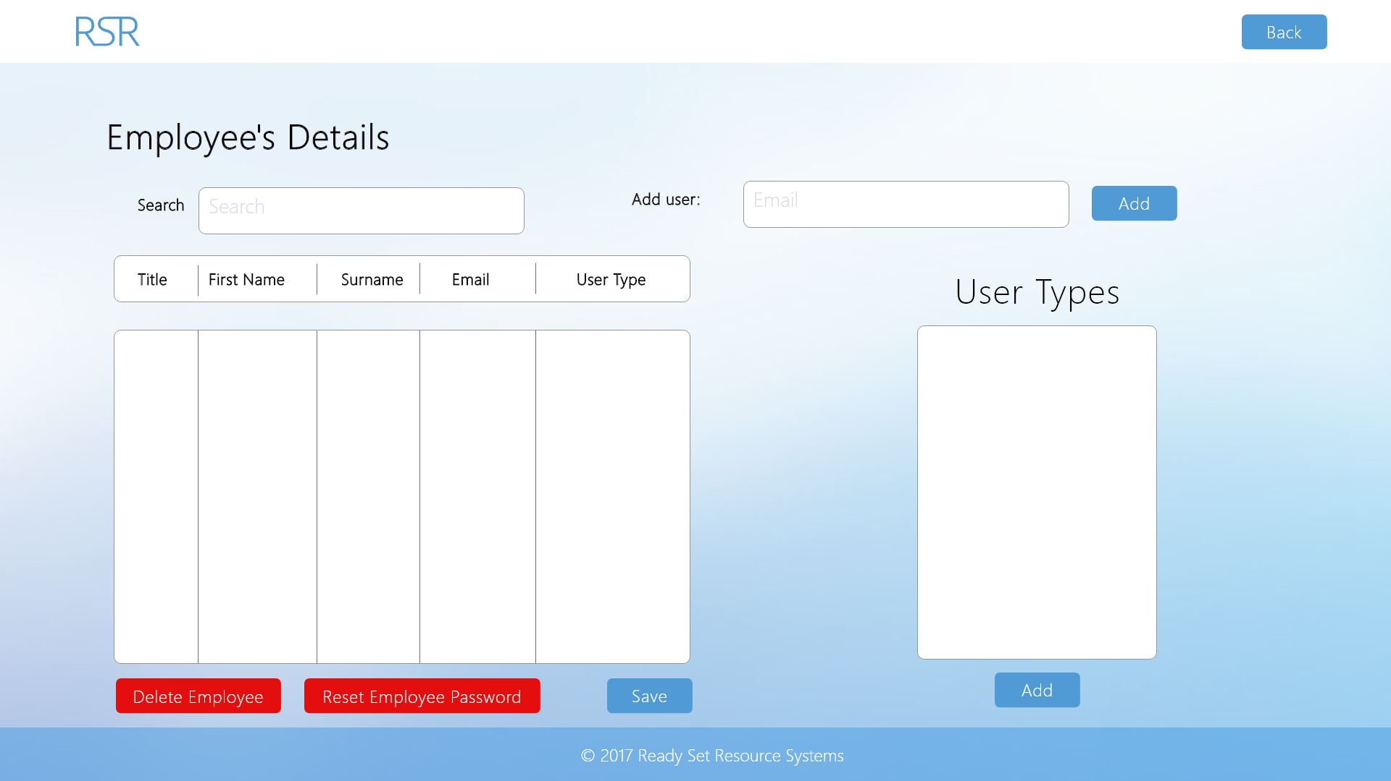

Input Permissible: - Search Query

- Add User Email

- Users’ Details

Error Messages:  - ‘Please add user by email’

- ‘Email in wrong fromat’

# 16.17 - UID /dashboard/ Work Log

| Entry | Description | Person | Date | Mins Spent |
| --- | --- | --- | --- | --- |
| 1 | Formatted the document | Aidan Marshall | 19/3/18 | 4 |
| 2 | Designed the website | Aidan Marshall | 19/3/18 | 267 |
| 3 | Added screenshots and page details | Aidan Marshall | 19/3/18 | 55 |
| 326 | | | | |